DISCLAIMER: This application is intended for informational and educational purposes only, based upon the research at the time the game was developed. The application is provided on an ‘as is’ basis. As a result Wayne State University is not responsible for any technical failure of the application; or any damage or injury to users or their equipment.

**Installation:**

1. Download the Game from the Healthy Urban Waters website
   1. What you will get is an installation package with the FATBERG Game and the software Unity, which is needed to run the game.
   2. The game is approximately 38,815 KB in size.
2. Unzip the Build package
   1. Use 7zip to unzip and extract the game files to a file of your choosing.
   2. Double click the  file to open the game.

**To Start:**

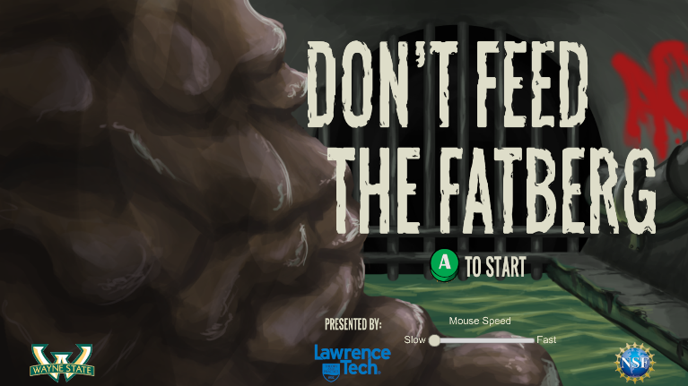

*Opening screen of the Fatberg Game*

1. Before starting the game, you have the opportunity to choose the speed of your mouse movements by using the sliding scale at the right lower area of the first screen



1. Once you have chosen your mouse speed, click on the A icon 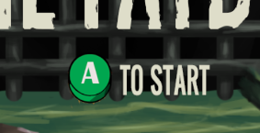

**Level One: In the Apartment**

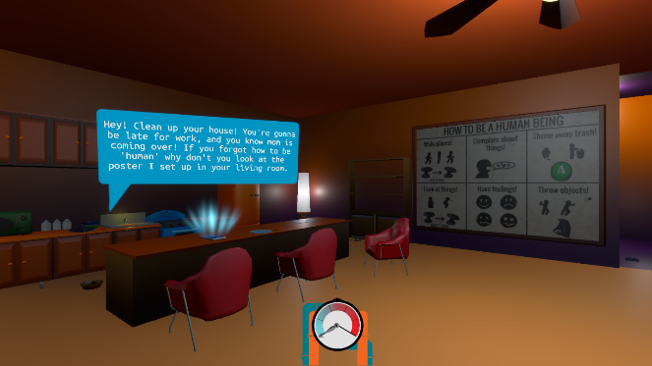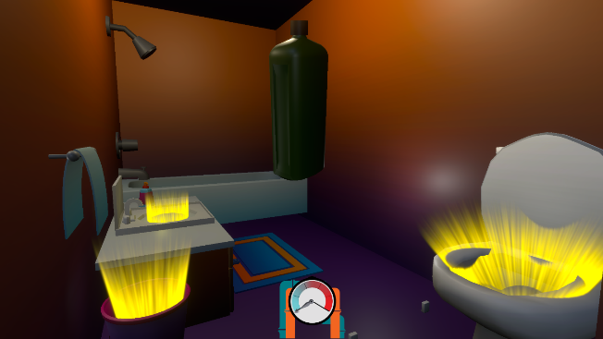

1. Game will start with the player in their apartment, with the tablet ringing and showing a message. Read it.
2. Start to pick up items in the apartment and throw them away.
   1. Use the Arrow Keys on your keyboard to move forward or back in the game
   2. Use your mouse to move up or down or side to side.
   3. Use the E key to pick up items
   4. Use the E key to drop items into the trash receptacles or in to drop them in general
      1. You know that you have hit the receptacle correctly when it splashes
3. This part of the game session is on a timer which the game has set, and will take you to the sewer to confront the Fatberg; try to get as many items disposed of before the timer goes off!

**Level Two: In the Sewer**

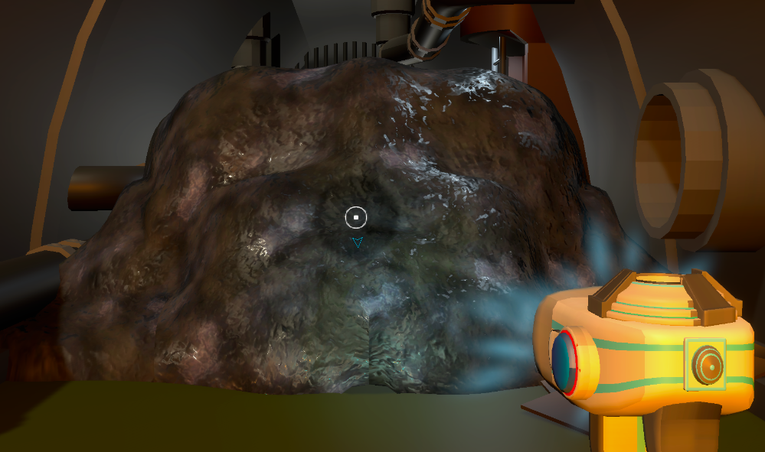

Once the game has taken the player to the sewer, the point is to find the items that have been thrown away improperly, and retrieve them.

1. Point the scanner to the correct area to find an item: The scanner pointer will turn red when an item is found within the Fatberg.
2. Use the space bar on your keyboard to retrieve the item from the Fatberg.
3. Use your mouse, arrow keys or your touch pad to rotate the dial to find an A

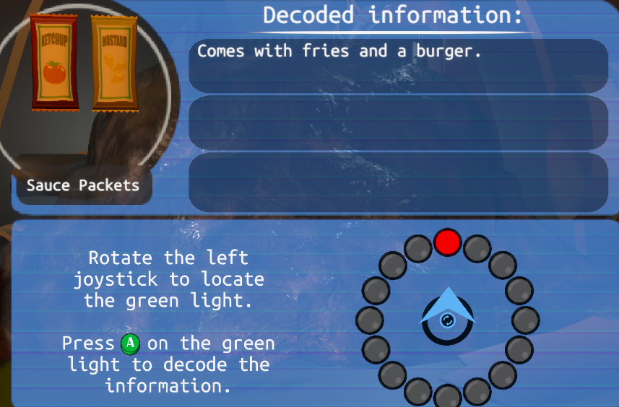

1. Select the A using your space bar.
2. Continue to dial and select the A to show information on why you should not throw the items down the sink or toilet.
3. You can search and retrieve all items that you have thrown down the sink or toilet. OR that your neighbors have put down the drain.
4. Once you have retrieved all the items the game will end

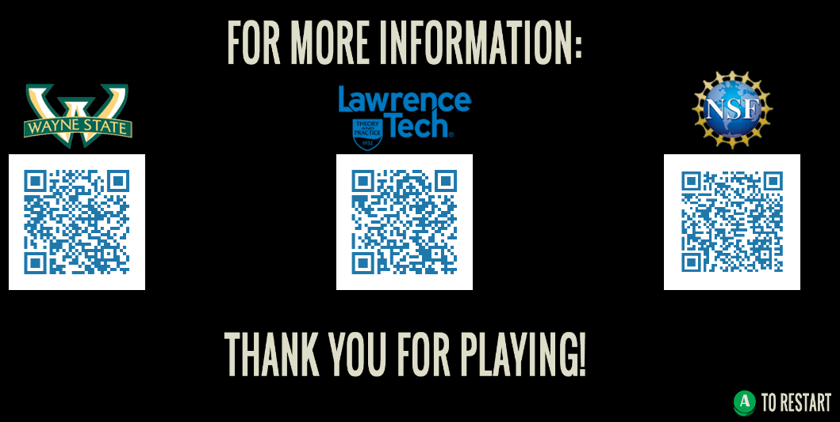

**Exiting the Game:**

At any time you may press your Escape key on your keyboard and exit the game. The game will provide a screen to either exit, continue, or go to the main menu. Choose one when the screen is displayed.

